**AI ASSISTED LAB EXAM 1**

**NAME:** N. Shiva

**BATCH:**12

**HTNO:**2403A51298

**Task 1:** **Create a Python function that converts an amount from one currency to another using exchange rates stored in a dictionary. Use GitHub Copilot along with VS Code. Use few-shot prompting.**

**Prompt:**

Write a Python function named convert_currency that takes arguments: the amount, source currency, and target currency. Use a dictionary of exchange rates to convert the amount from the source currency to the target currency. Return the converted amount. Use comments for clarity.

**Code:**

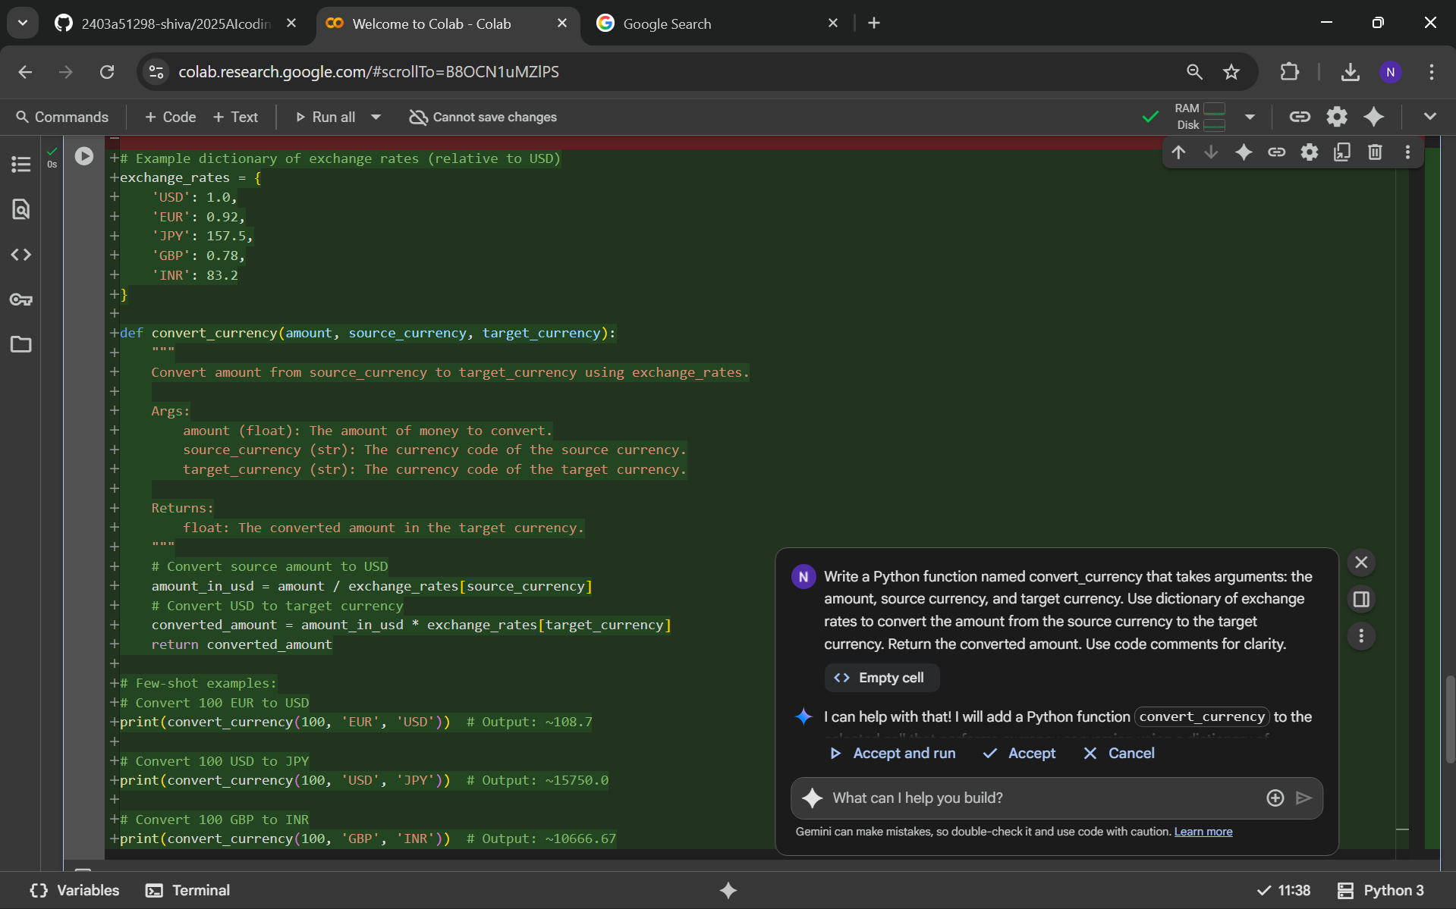

**Output:**

108.69565217391303

15750.0

10666.666666666668

**Task 2:** Write a Python program to extract all email addresses from a block of text using regular expressions. GitHub Copilot along with VS Code. Use zero shot prompting

**Prompt:**

Write a Python function named extract_emails that takes a text string and returns all email addresses found within it, using regular expressions. Use code comments for clarity.

**Code:**

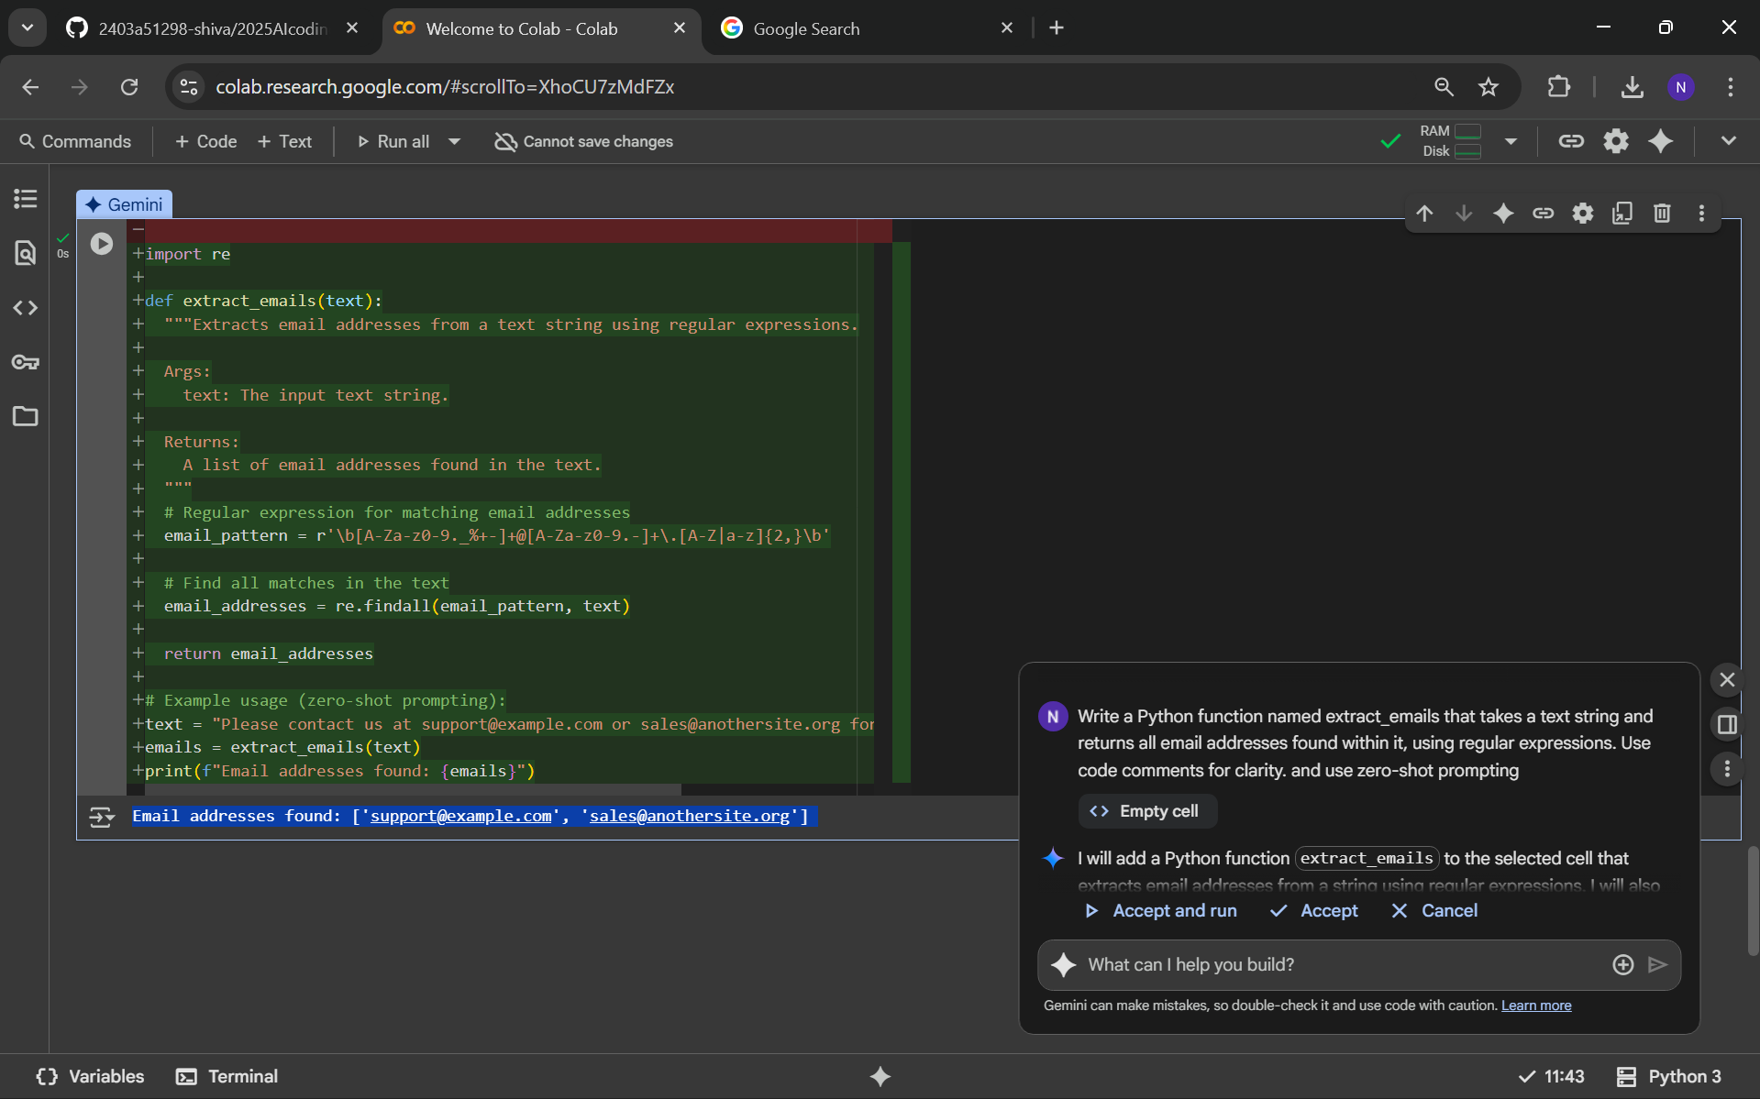

**Output:**



**Task 3:** Given a list of movies with their genres, write a Python function that recommends movies based on a user's preferred genre. Use the Cursor AI tool. Use a few-shot prompting

**Prompt:**

Write a Python function named recommend_movies that takes a list of movies and a preferred genre, and returns the titles of movies matching that genre. Use code comments for clarity.

**Code:**

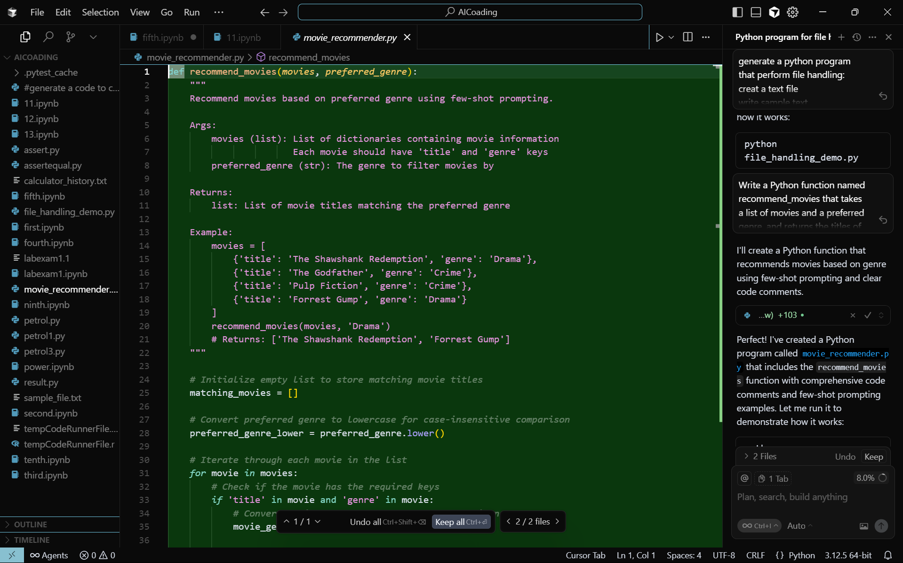

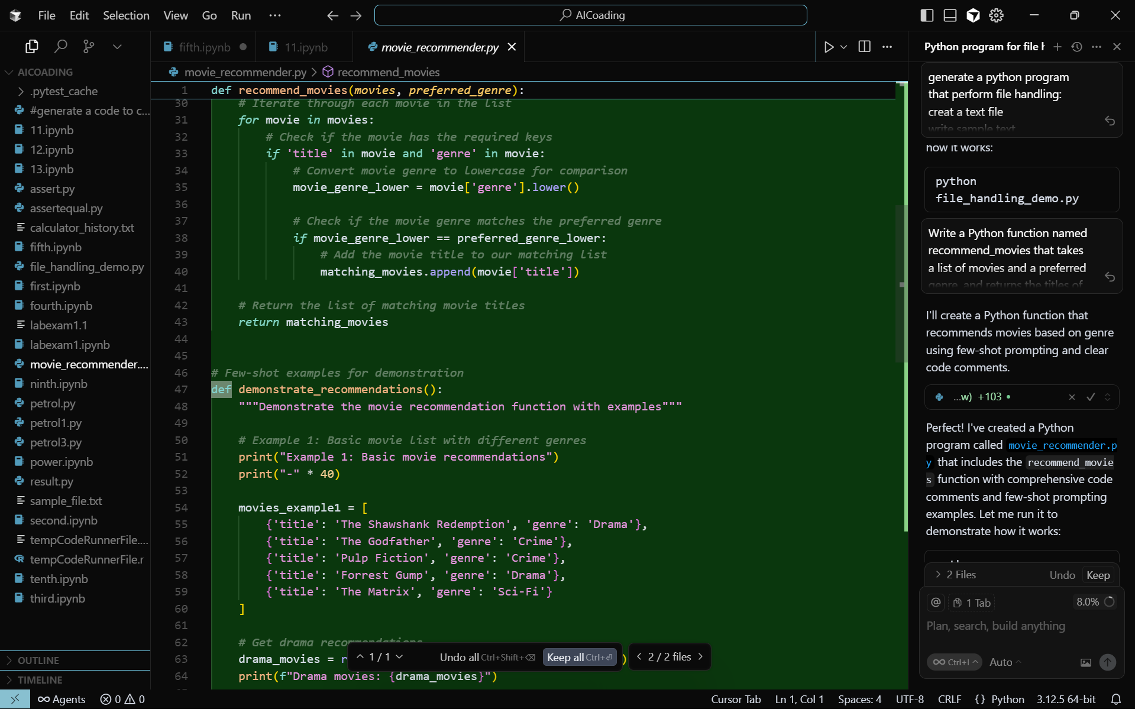

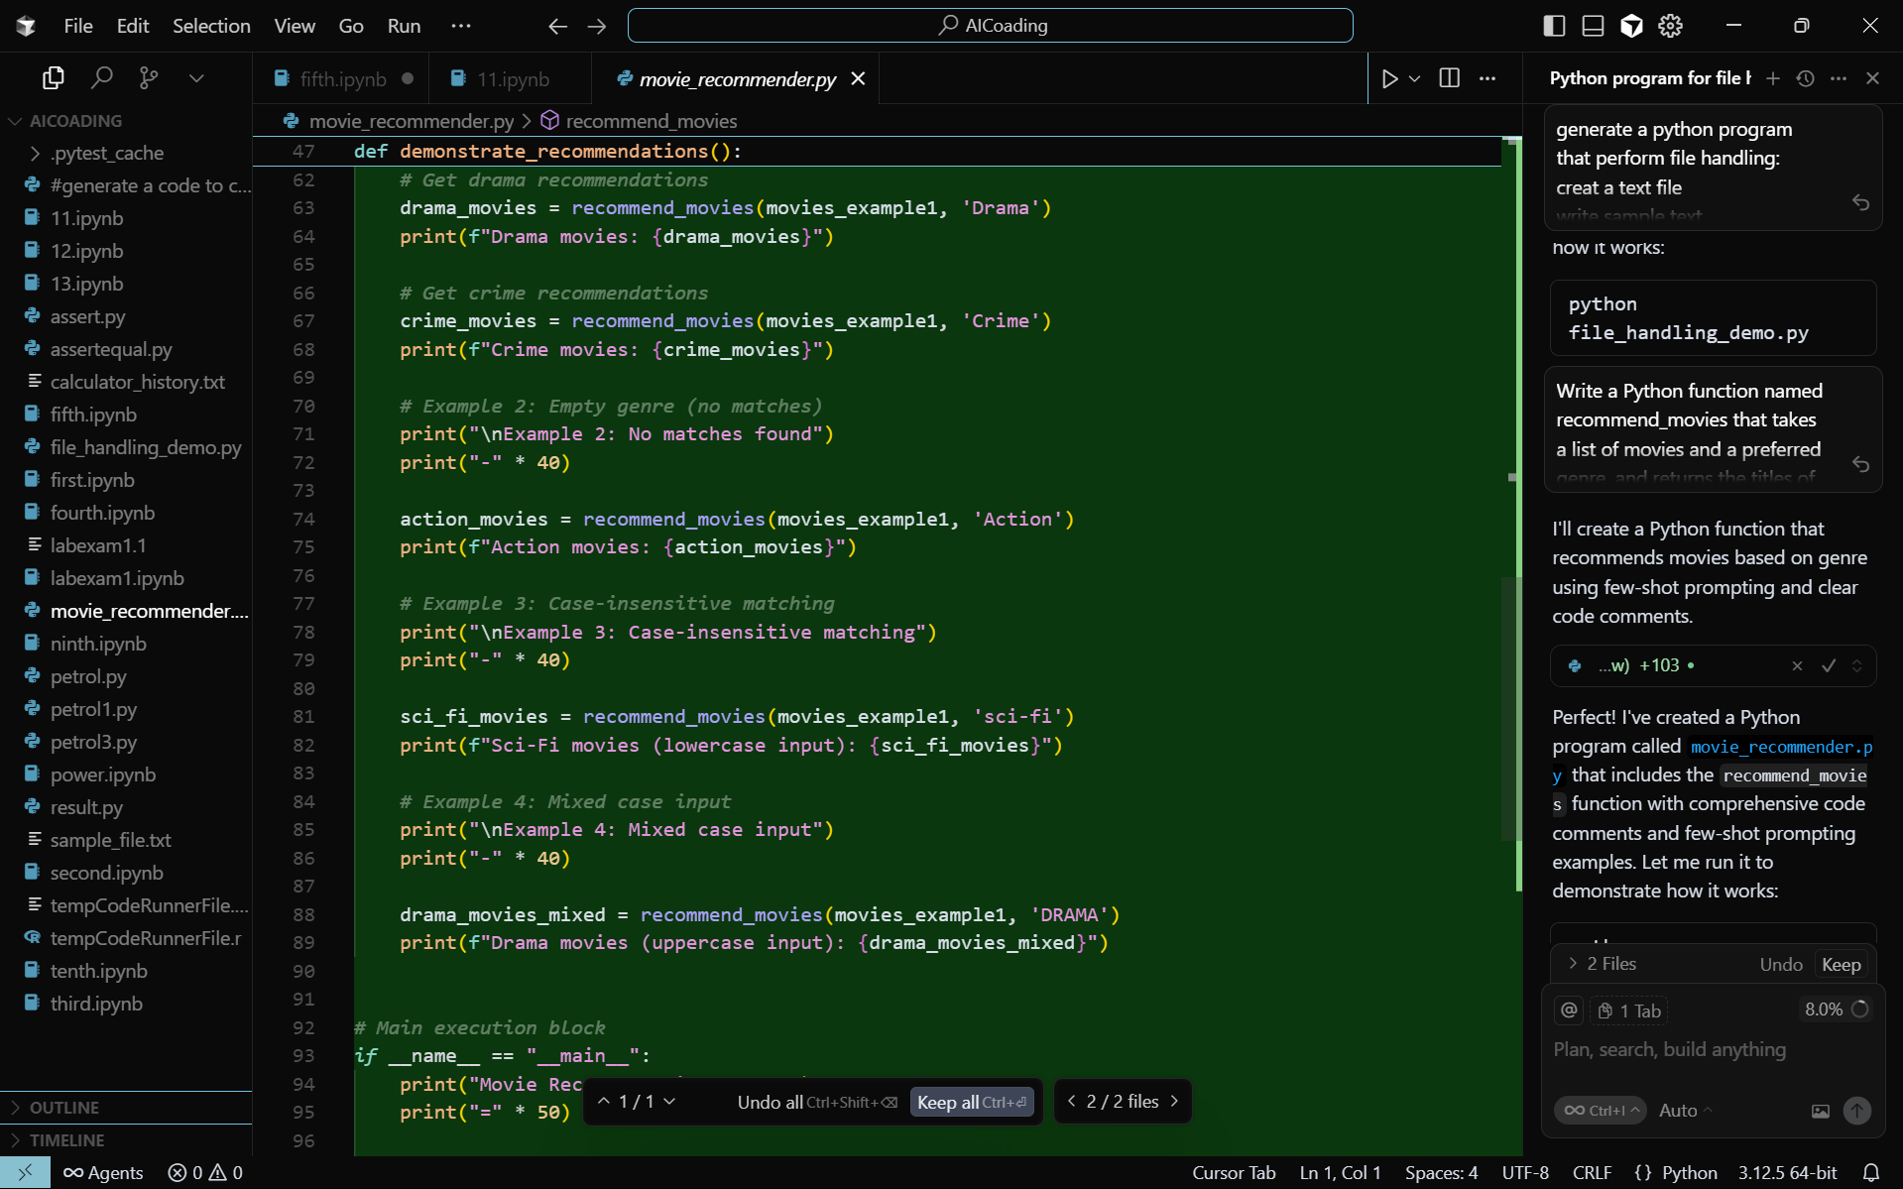

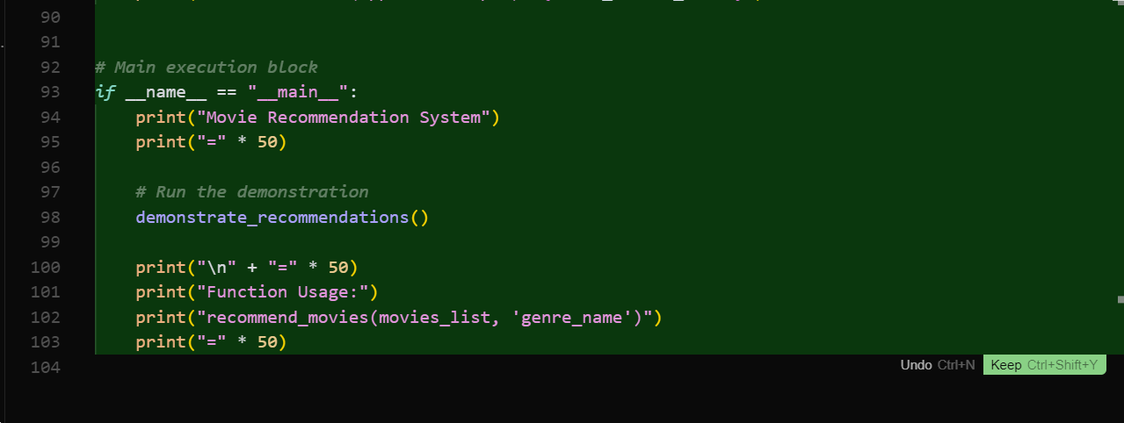

**Output:**

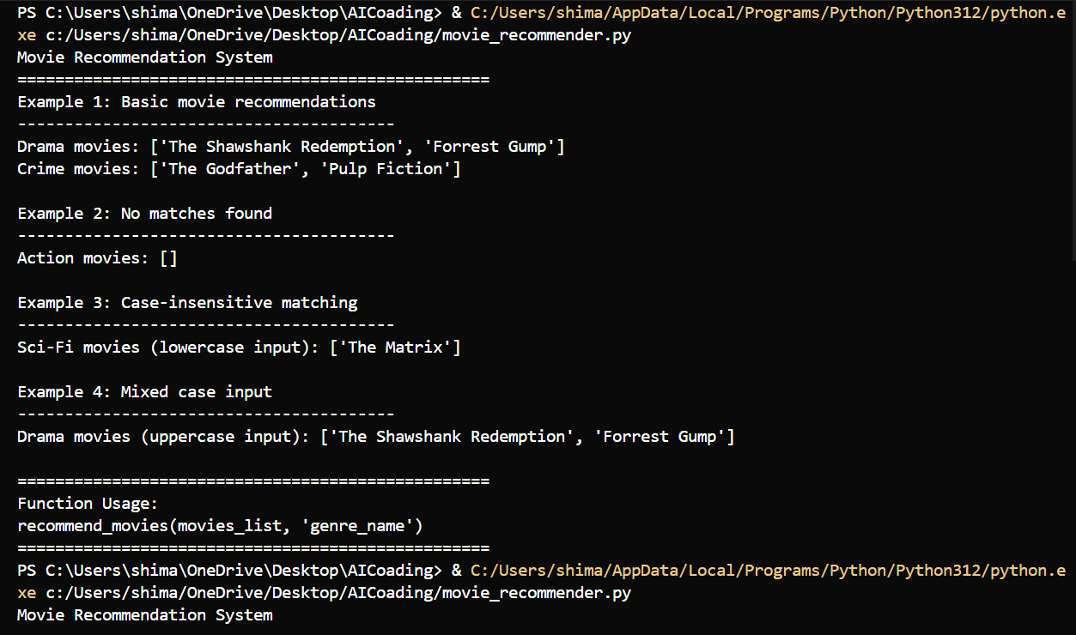

**Task 4:** Write Python code that reads a CSV file containing student names and marks in 3 subjects. Calculate the total and average marks for each student. Use the Cursor AI tool

**Prompt:**

Write Python code that reads a CSV file containing student names and marks in 3 subjects. For each student, calculate the total and average marks, and display the results. Use code comments for clarity

**Code:**

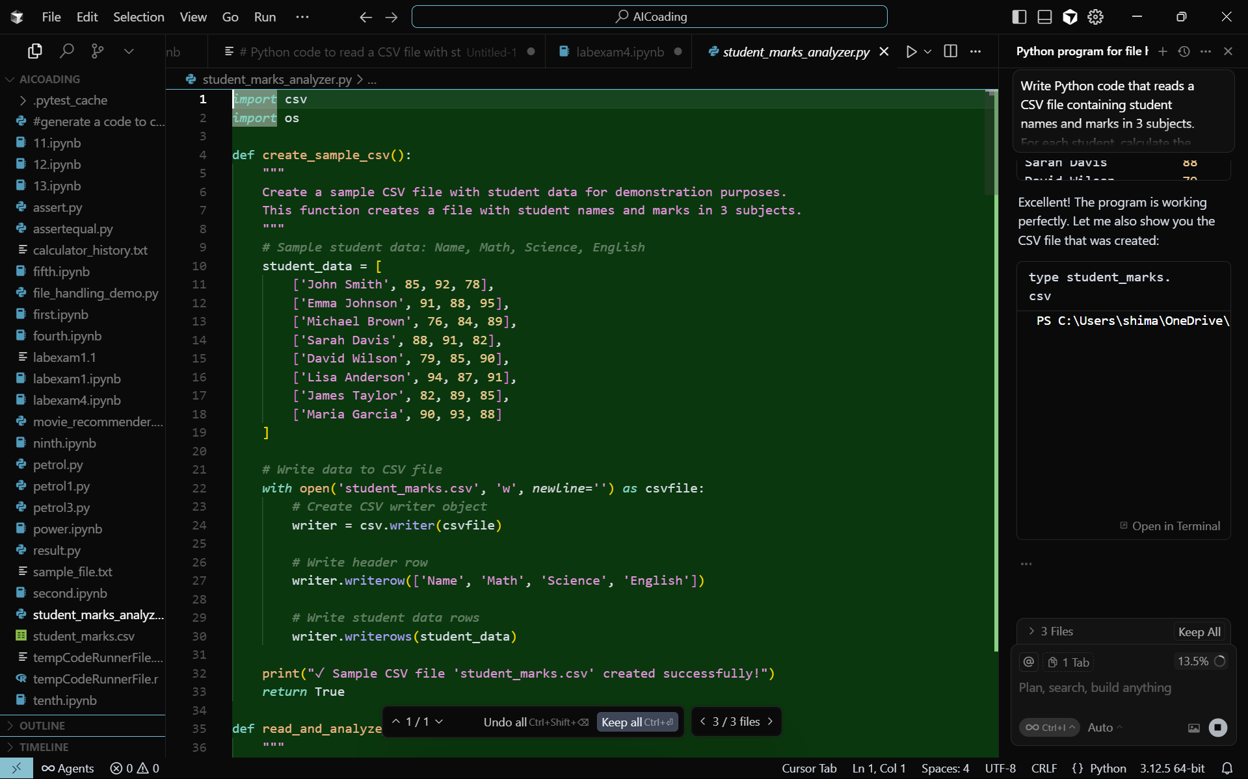

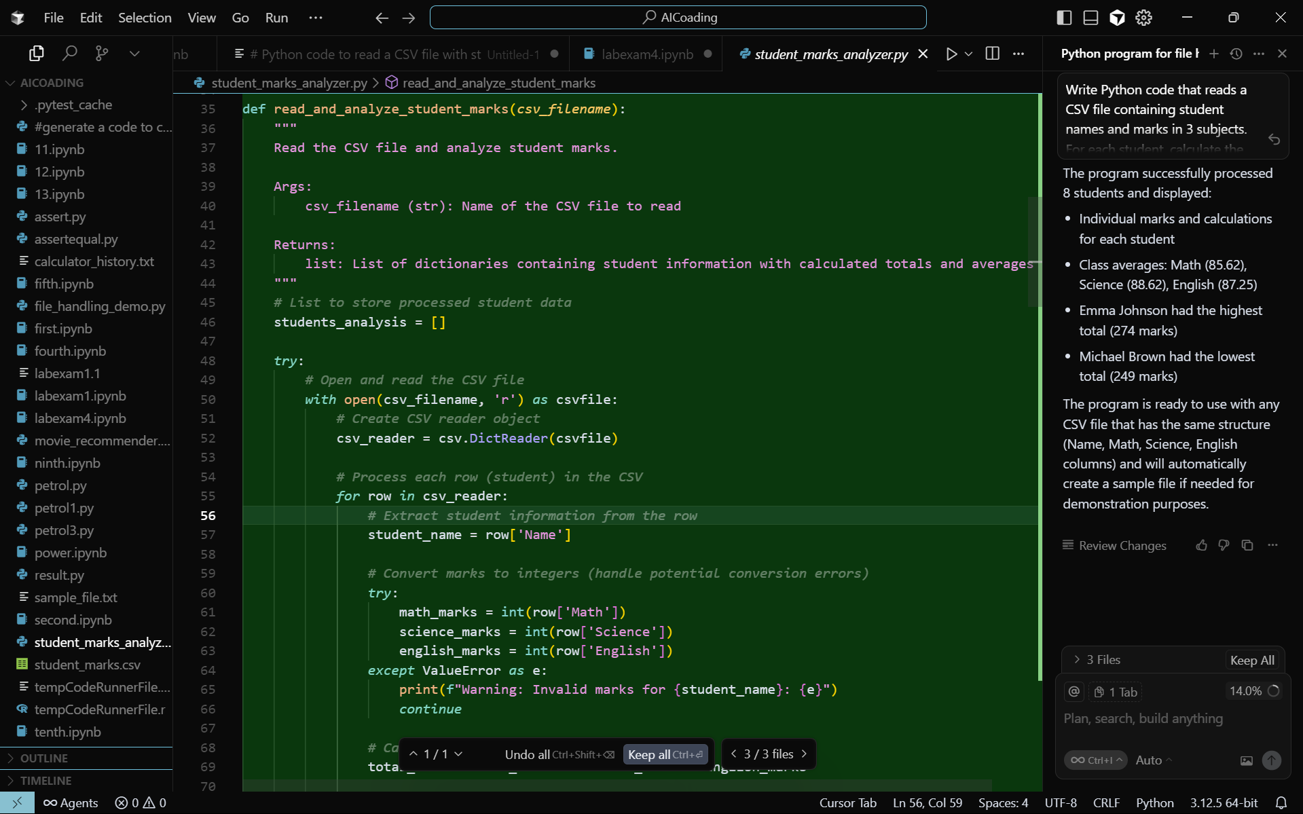

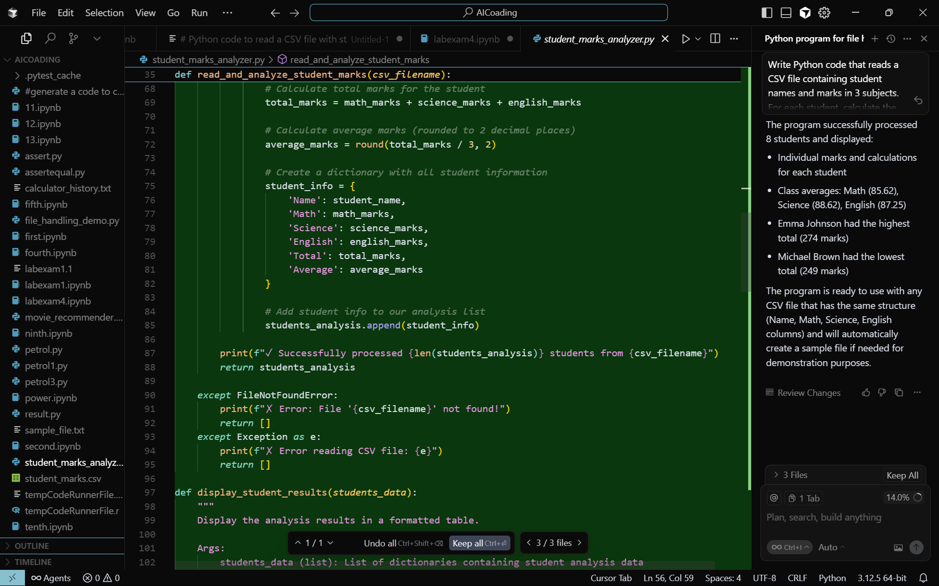

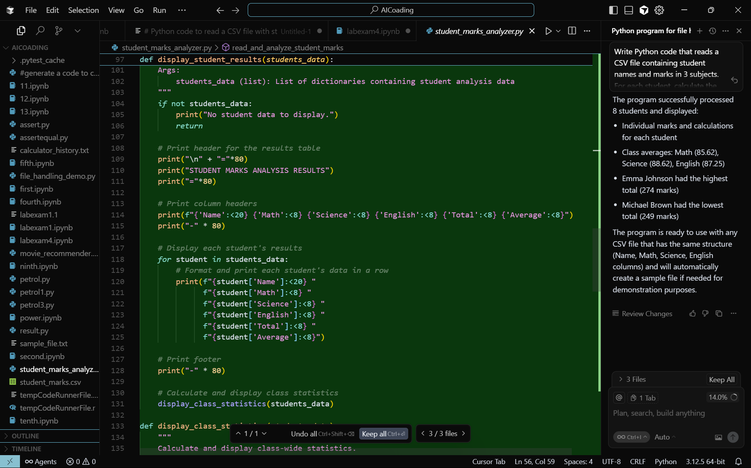

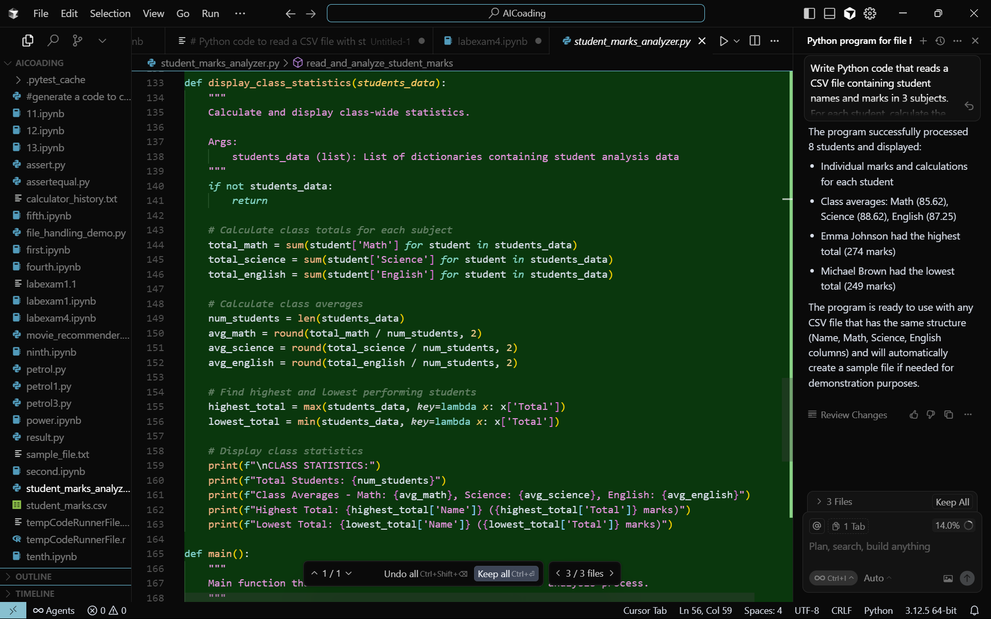

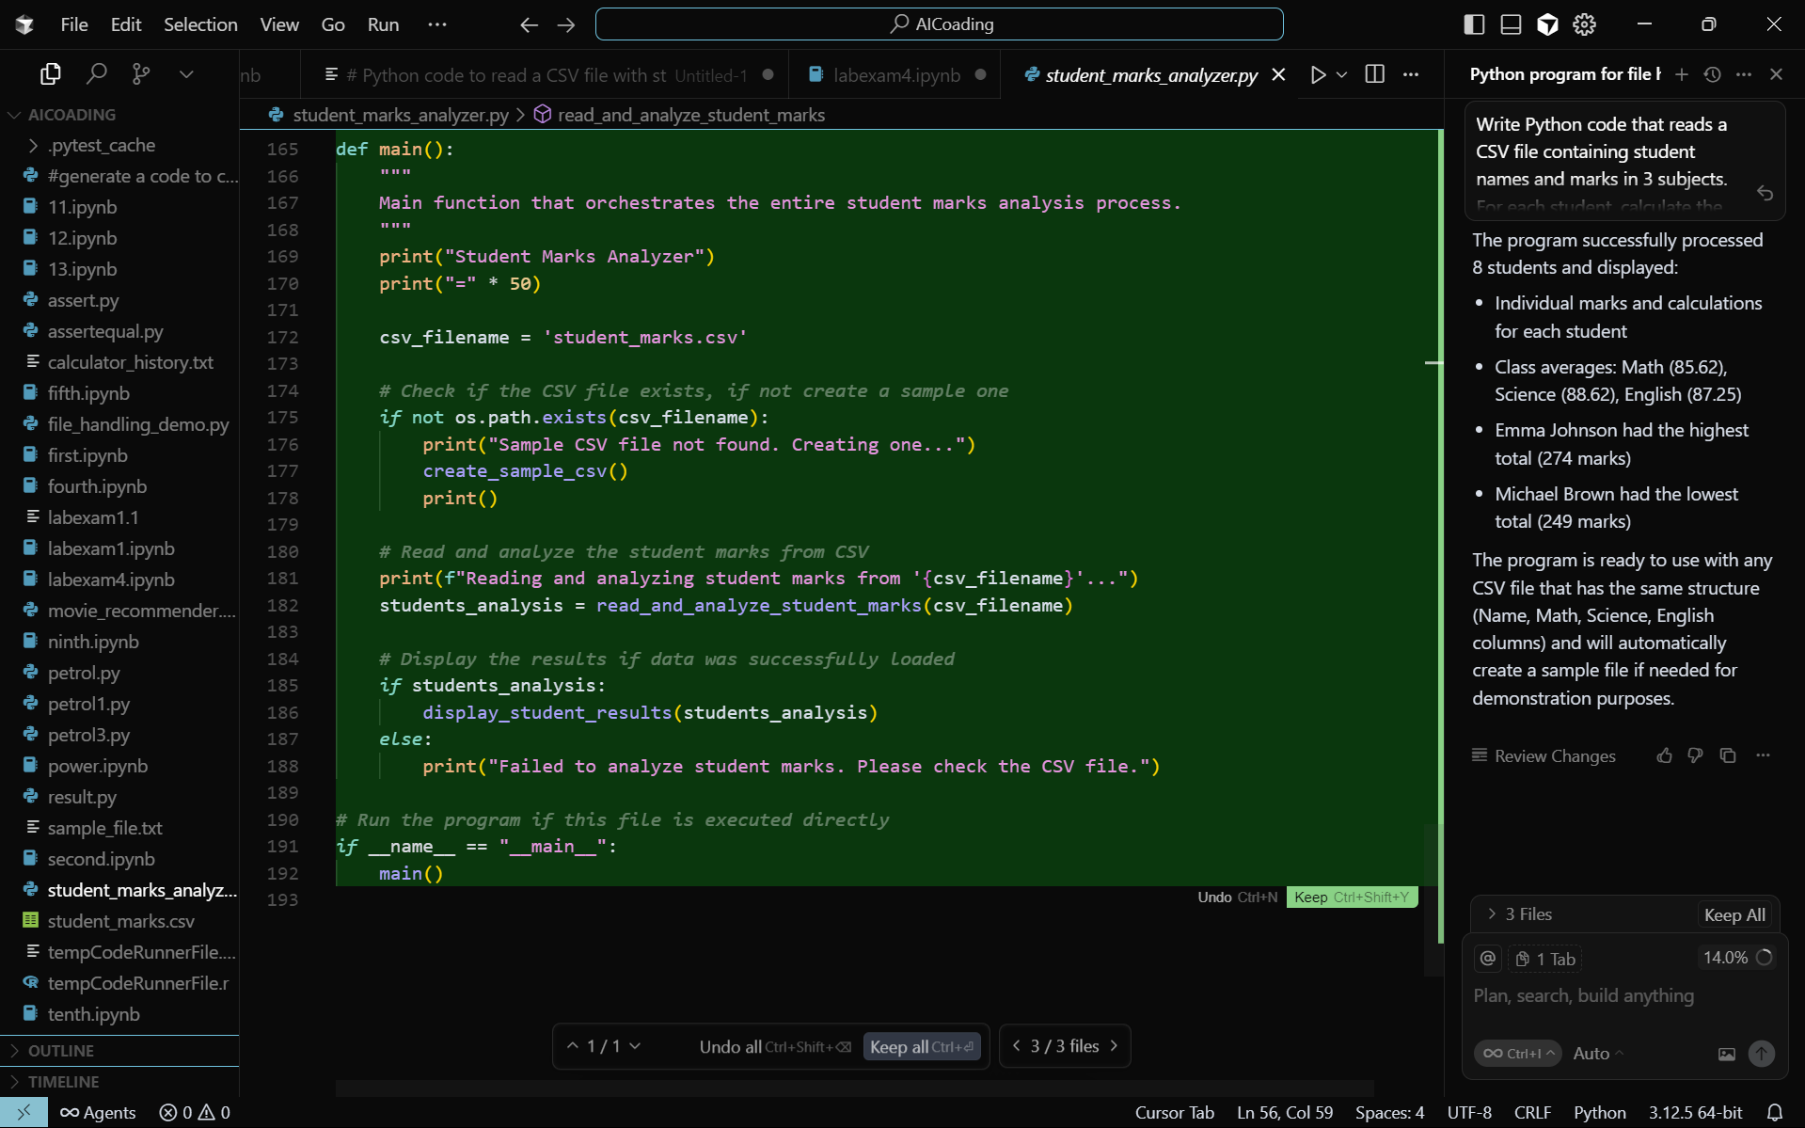

**Output:**

